Matt Bell
SPAN 325
Movie Reflections 2
Bye Bye Brazil
Brazil
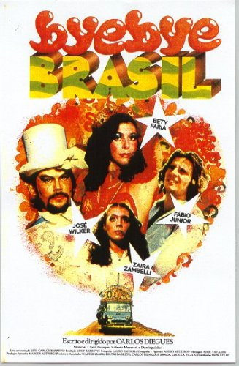
This movie showed more of a transitioning time for not only Brazil, but human innovation versus classical entertainment. The movie showed the struggle of the carnival people to keep the people’s attention while also showing the country itself.
What was also pointed out in class by the professor was the cultural mentality of ‘nudity’: Brazil is open and embraceful of people and bodies. According to the professor, Brazilian people find the body beautiful. In contrast to my experience in Japanese culture, the people of Japan are more reserved and don’t typically show their bodies. However, the culture is ok with public bath nudity: when I lived in Japan, it was hard at first to feel comfortable getting completely nude and walking among other nude guys into the showers then the bath. However, I became comfortable with the custom due to it being a common form of relaxation. I guess like any culture, each has their own.

Strawberry and Chocolate
Cuba
The film took a look at the concept of homosexuality in Cuba and how it was portrayed. The main character had created a friendship with a man who was the image of what gay men were: very flamboyant, artsy, and anti-revolutionary. The thought of someone being homosexual was considered to be “non-Cuban” and even forced to be removed from the country.
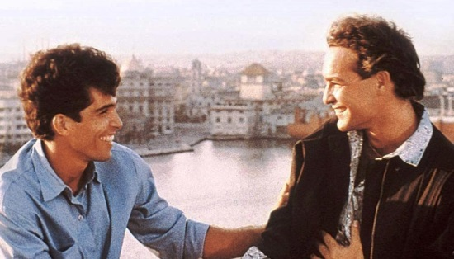
The image that the people of Cuba held was one of constant negative correlation. Whatever they were involved with (those who were homosexual), it was seen as prohibited. The movie tried to also prove that even though those who were homosexual were being rejected by their home, they too are Cuban and support their home. Regardless of the slander that was being promoted by the Castro regime, those of homosexual orientation still called Cuba home.
There was a moment of dialogue between the two, Diego and David, where Diego was defending his own right to be Cuban and his own love for his country. Castro had soiled the image of his people and created subjugation and disillusionment.

The Forgotten Ones
Mexico
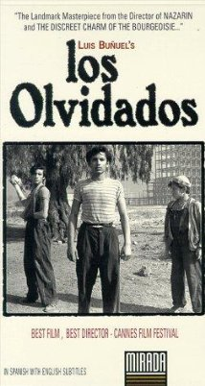
A controversial movie that highlighted the rough lifestyle of living in the slums of Mexico. Like the movie City of God, both movies show that life on the streets are tough and filled with violence. While the movie in Brazil took place in the 1970s in correlation with the drug trade, The Forgotten Ones took a look at the people and their social struggles.
The boy in the film who was trying to earn his mother’s love was trying to earn it through working and earning money for the family. Somehow, it seems that regarding the mother and father’s relationship, the mother had some disdain toward him, and was driving the negative feelings and energy to the boy. There was even doubt if the son was a ‘good boy’ and let him be taken away to the correction facility.
The correction facility also shows what the government did to and for the kids who were troublemakers: put into a central area and raised to learn how to write and a trade. That actually seems like a good idea, to give the kids an opportunity to have skills and abilities when they grow up.
Interestingly, there was a cultural point that was interesting. When kids were sent away for reform, in the movie, there was a ‘farm’ where the kids were kept to stay, taught how to write, read, and a trade. Through most of the movie, it kept me thinking if there was a solution, and this aspect was put into the movie 3/4s of the way through.

Guantanamera
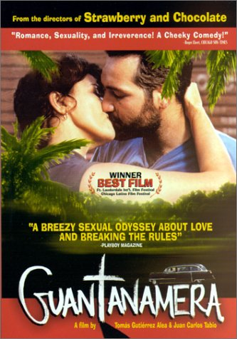
Location: Cuba
the film is noted for depicting life in Cuba during the "Special Period" of the 1990s, a period of relative poverty for Cuba following the termination of Soviet aid to the country. The male protagonist, for example, was an engineer under the Soviet-supported regime, and now makes a living as a truck driver.
The film is noted for depicting life in Cuba during the "Special Period" of the 1990s, a period of relative poverty for Cuba following the termination of Soviet aid to the country. The male protagonist, for example, was an engineer under the Soviet-supported regime, and now makes a living as a truck driver.
I feel that this movie first portrays how the government was viewed through Adolfo. Adolfo, controlling, cold hearted, and focused on personal fame, was a character that came to be disliked and even seen as an annoying person. At the end, when giving a eulogy for the deceased mother of his wife, he cared more about the people being there to listen to him instead of caring about how much the rain was pouring down and soaking everyone. Adolfo didn’t even notice when his wife rode off with the Mariano.
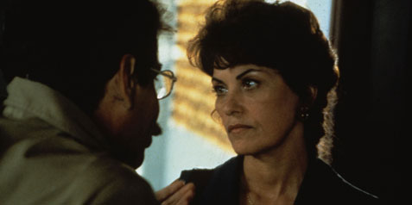
Speaking of the wife, Georgina, I feel like she most likely embodied the women of that time. While they possessed knowledge and were educated, they were looked down upon and controlled. Adolfo seemed to have portrayed lack of interest in her and didn’t like it when she tried to break from more conservative based clothing. Anything that was too flashy was considered negative and looked down upon. I can imagine that this was showing how the government couldn’t let the people be free, expressive and wanted to keep things based on how the like it.
During the 1970s through 1990s, it seems that women had an opportunity to enter the workforce, which increased by 22% during that time, and now represent 43% of the working population. However, the film could have been portraying the concept of women working who are married or women in general.
http://www.angelfire.com/pr/red/cuba/status_of_cuban_women.htm
Mariano was also representing the people: under the soviet-union-based economy, those who had high ranked jobs, such as engineers, were put into other positions, such as truck drivers, which was portrayed through Mariano.
Economic Aspect through Guantanamera:
in the early 1990’s, cuba was going through a period of time known as “The Special Period in Time of Peace (Spanish: Período especial)” which was cuba’s economic crisis due to the dissolution of the soviet union. this social depression was most severe during the early and mid 1990’s because of the instant and severe shortage of hydrocarbon energy resources in the form of gasoline, diesel, and other petroleum derivatives that occurred upon the implosion of economic agreements between the petroleum-rich Soviet Union and Cuba. The period radically transformed Cuban society and the economy, as it necessitated the successful introduction of sustainable agriculture, decreased use of automobiles, and overhauled industry, health, and diet countrywide. People were forced to live without many goods they had become used to.
The dissolution of the Soviet Union hit the Cuban economy severely. The country lost approximately 80% of its imports, 80% of its exports and its Gross Domestic Product dropped by 34 percent. Food and medicine imports stopped or severely slowed. The largest immediate impact was the loss of nearly all of the petroleum imports from the USSR. Cuba's oil imports dropped to 10% of pre-1990 amounts. Before this, Cuba had been re-exporting any Soviet petroleum it did not consume to other nations for profit, meaning that petroleum had been Cuba's second largest export product before 1990. Once the restored Russian Federation emerged from the former Soviet Union, its administration immediately made clear that it had no intention of delivering petroleum that had been guaranteed the island by the USSR; this resulted in a decrease in Cuban consumption by 20% of its previous level within two years. The effect was felt immediately. Entirely dependent on fossil fuels to operate, the major underpinnings of Cuban society—its transportation, industrial and agricultural systems—were paralyzed. There were extensive losses of productivity in both Cuban agriculture — which was dominated by modern industrial tractors, combines, and harvesters, all of which required petroleum to run — and in Cuban industrial capacity.

Between Pancho Villa and a Naked Woman
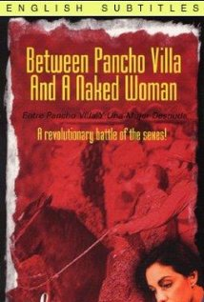
Mexico
This movie was a comedy about a female writer and a man who could not commit. The movie uses Pancho Villa to represent the ego of the main character. It seems that Mexican culture shows great respect for Pancho Villa and what he did.
About Pancho Villa:
José Doroteo Arango Arámbula (5 June 1878 – 20 July 1923) – better known by his pseudonym Francisco Villa or his nickname Pancho Villa – was one of the most prominent Mexican Revolutionary generals.
As commander of the División del Norte (Division of the North), he was the veritable caudillo of the northern Mexican state of Chihuahua. Villa was also provisional Governor of Chihuahua in 1913 and 1914. Although he was prevented from being accepted into the "panteón" of national heroes until some 20 years after his death, today his memory is honored by Mexicans. In addition, numerous streets and neighborhoods in Mexico are named in his honor.
Villa was famous during the Revolution and has remained so, holding a fairly mythical reputation in Mexican consciousness. As the Centaur from the North he was considered a threat to property and order on both sides of the border, feared, and revered, as a modern Robin Hood. In Mariano Azuela's novel The Underdogs, anti-federal soldiers talk about him as an archetype of an anti-authoritarian bandit: "Villa, indomitable lord of the sierra, the eternal victim of all governments ... Villa tracked, hunted down like a wild beast ... Villa the reincarnation of the old legend; Villa as Providence, the bandit, that passes through the world armed with the blazing torch of an ideal: to rob the rich and give to the poor.

Bitter Sugar
Cuba
This movie highlighted the social concepts and views on different aspects around leaving Cuba, Spain, and the Cuban government.
The main character and his girlfriend both had plans to leave Cuba: Gustavo hopes for a scholarship to study aeronautical engineering in Prague, the other, Yolanda, wants a career as a dancer and longs for the riches of Miami. Even though the main character was promised money to leave to study, the truth was, there was no money for his to go abroad and he was forced to stay in Cuba. While the two were dating, the guy kept talking about leaving: the girl seemed to have been having an affair with a man from Italy. That didn’t work out and instead, she took a raft and floated to Florida.
In between this love-story, there were other cultural aspects of Cuba that stood out. First was money: the dollar was becoming more valuable and making the peso worthless. This led to Gustavo’s father leave to go back to work. Even though Gustavo’s father was a prominent in the field of Psychology, he was led to go work as a piano player for a hotel. But not just any hotel, a foreigners only hotel.
The hotels that were starting to pop up in Cuba were from Spain: this caused for more economic struggles and more struggles for the Cuba people. For example, when Gustavo wanted to drink at the beach at the bar that was owned by the hotel, they were prohibited from drinking there. Apparently, there was a rule to keep locals off the premisis and only have it used by the tourists. Even more restrictions on the Cuban people.
Furthermore, Gustavo had a younger, more rebellious brother who loved rock and roll. However, due to his love and want to be free and rebellious, the police had brutally beat him and shaved off his hair. Those in power seemed to dislike the influences and other cultures that were outside of Cuba and surpressed them. Since Bobby could not take it, he decided to inject himself with AIDS, which was a form of political protest during that time.
This led Bobby to being put into a sanitarium. Here’s some information on Cuban sanitariums:
When H.I.V. testing began in Cuba in 1986, infections were found first in soldiers who had been in Africa. Initially locked in the national Naval Hospital, they were frustrated, since they were still healthy. There were escapes on bedsheet ropes; rum was smuggled in.
As their numbers grew and more civilians tested positive, the government opened sanitariums — both to keep the infected from having sex with anyone uninfected and to help them die comfortably.
At first the institutions were run by military doctors and guarded by soldiers; patients had home visits only with escorts.
But life inside was not brutal. Inmates got food, medical care and their old salaries; theater troupes and art classes formed. Gay men could live together, which was not true in the macho culture outside.
http://www.nytimes.com/2012/05/08/health/cubas-aids-sanitariums-fortresses-against-a-viral-foe.html?_r=0

Havana: The Art of Making Ruins
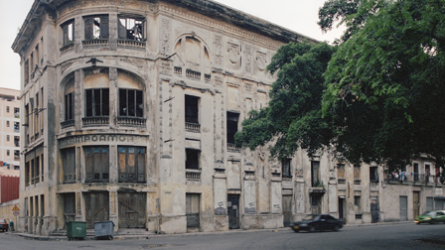
Cuba
This was a documentary that looked at modern-day Havana and interviewed people who are living in Havana now. The buildings of Havana today are considerably torn down and in bad shape. Their living conditions aren’t the best and seem to be in the worst condition possible. This documentary shows that why the people are staying there is the pride, good memories, and love for its history.
Even though conditions are low, spirits are high. The way that the government handles the buildings is through pure flow of time: instead of tearing them down and building anew, the government lets the buildings collapse before renewal. There was a quote from a person that said that “once it goes down, they’ll just make a new hotel in the area”. This shows that economic importance is placed on tourism and less on its people.
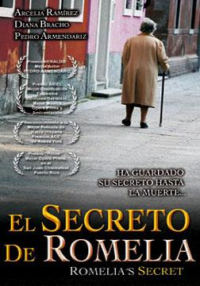
The Secret of Romelia
Mexico
This movie shows three generations of women and the Mexican culture’s perception of women during the course of three generations. Rather than a whole broad view of women, the film shows the societal pressures of the grandmother’s generation and the difference between the daughter and granddaughters.
During the grandmother’s era, virginity and purity were different compared to how it’s treated now. Due to the accusations of Romelia not being a virgin, she was seen as a whore and social outcast, throwing her away from her home and forcing her to leave to the city. Her secret and past were kept a secret and never shared to anyone, even her own daughter. It seems that the ear Romelia grew up in, matters such as this weren’t to be spoken of, and even through time changes, the thinking and mind of her youth still remained.
The daughter of Romelia showed that she too had issues with her own marriage, but was able to find some sort of love again during the trip. In contrast to Romellia, she had a daughter, but didn’t seem to marry again. The cultural and era differences show that concepts of love and commitment are different.

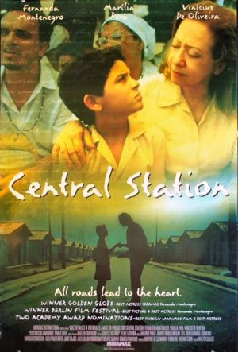
Central Station
Location: Brazil
Opposite to ‘City of God’, Central Station is a lighter movie about a boy losing his mother and a local letter writer’s adoption of the kid. Dora is a middle-aged woman and Josue is 9 years old. At first Dora didn’t really care for the kid and left him alone at the station. However, as a cultural aspect, the movie points out the issue of kidnappers at the stations. Our class’s professor not only pointed this aspect out, but also the matter of crime. There was a scene right after this of a teen/young man took a piece of food, ran from the cops, and was shot and killed.
Anyway, Dora decides to get rid of the kid and then gives him up for cash. This is also another cultural aspect was going on: apparently stray kids could be taken, given to someone, and resold to someone for manual labor. But Dora realizes what she has done, gets back Josue, and decides to go on a journey to find his father. The movie takes Dora and Josue through parts of Brazil and the cinematography highlights the natural beauty of the country.
The movie takes us to a town where a religious festival is taking place and gives another cultural look into how the people of Brazil/South America are religious and how they celebrate it. Even though it was a short aspect of the movie, it’s also a point in the movie where the two don’t have cash anymore where Dora once again does her letter writing stand. From the words of the people who want something to write/say, we can see the spiritual side of the people and what they’re thankful for.
Dora and Josue reach a place in which they come upon Josue’s step brothers, but the father still gone. Dora decides to leave behind Josue with his step brothers as she leaves to go back to Rio.
The Man Facing Southwest
Location: Argentina
This was a good movie. The ending a little sad, but goes well with the concept of the character’s portrayal of modern “Jesus”.
Following the main character, you can see that he has what appears-to-be psychic abilities and considerably high intelligence, which is what a lot of wish to be born with: what John Doe ended up doing was using it to help people, which was amazing. In part of the movie, John Doe had questioned “who’s the one that’s really sick?”, making a point about modern society. How can we say that we’re fine when we cannot even be in the right mind to take care of our fellow man? The movie/director is trying to make a point putting John Doe into the mental ward to question the human mind.
As for the psychiatrist, he’s portraying the common man and the denial of the whole “Jesus” complex and he’s from somewhere else. He took a great interest in John and even wanted him to try and enjoy parts of society, such as orchestra. The part that confused me was when he met John’s friend/sister. Even the two of them had a moment of passion, he kicked her out once he found out that she was just like John. Not sure if the Doctor knew what he believe was real or not. Also, as for the sister, she always would switch shoes once she left the mental ward. That was never well explained.
Week 2
The Official Story
Location: Argentina
Another good movie, a heartbreaking story about the 1980s issue on stolen children and the victimized parents during the Dirty War in Argentina.
I had no idea about this matter before coming to this class: I did not know that this was something that had been going on during that time in Argentina. The movie really points out how many women had their kids taken from then during the march/rallies.
What was also a great portrayal was the look at the economic situation/mentality of that time. The main father character was someone in power with a lot of money, while the rest of his family found joy in living a simpler life.
Women on the Verge of Breaking Down
Location: Spain
This time, the movie was about a woman named Pepa and her love for a man named Ivan. Both are voice actors and the movie seems to be making it seem that Ivan is avoiding her. The movie first makes Pepa seem like someone who is obsessed with Ivan, but is just actually trying to give back his stuff and move on from him. Mid-way through, it also involved Pepa’s friend and Ivan’s son, who was played by Antonio Bandarez. The son was just as playboy-ish as his father as he was kissing and flirting with Pepe’s friend when his girlfriend/fiancé was out cold from drinking the tomato juice with sleeping medicine in it.
It’s actually a funny movie and the flow was very sporadic. It was mentioned that the director of the movie had experience before making TV dramas, so it makes sense how certain things made it into the movie, such as Antonio Bandarez randomly making out with Pepa’s friend several times while his fiancé was out cold and asleep from the sleeping drink.

Week 3
All about My Mother
Location: Spain
I thought that the movie was going to be about the relationship about the son and mom, but the movie took a sudden turn as the kid was hit and killed by a car. The setting of the movie went from Madrid to Barcelona, which also was a surprising jump. The setting when Manuela was driving in a cab in what seemed to be a circling car pool in the middle of nowhere. The teacher explained that this was an area for prostitution picking-up. The movie then introduced us to Manuela’s friend Agrado, who not only was a transvestite, but also representative of Spain. The professor said that Spain is made of many elements: its different and stable and doesn’t need explain itself. Anyway, we’re also introduced to a girl named Nina whose role was to be pregnant and ironically name her child after Manuela’s late son AND be impregnated by the SAME guy who knocked up Manuela 17 years previous. Then Manuela had also visited the same play that Manuela had seen with her son before he died and created a relationship with Huma and her co-star Nina. Huma became close with Manuela while Nina stayed hooked on drugs and ended up dying (not due to the drugs, but fighting w/ Huma). The movie also ends with Manuela meeting her ex, and what’s more is that the ex is also a transvestite who got to see the son he didn’t know he had (via picture).

